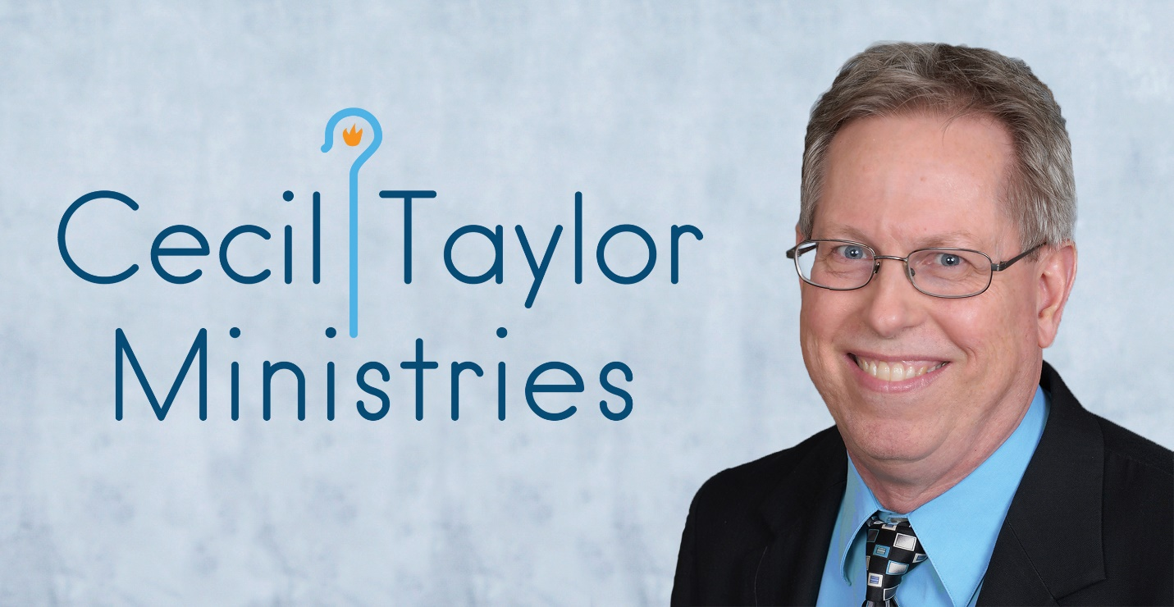

Contents
Personal Testimonials of Cecil, His Work, and His Speaking 2
Reviews of “The Next Thing: A Christian Model for Dealing with Crisis in Personal Life” 2
Reviews of “Live Like You’re Loved: Steps to Living in the Freedom and Immediacy of God’s Love” 3
Reviews of “The Legacy Tree: A Christian Model for a Life of Significance” 4

Personal Testimonials of Cecil, His Work, and His Speaking

“Cecil Taylor is one of the finest teachers I know. His take on the Bible and discipleship is always fresh and helpful. He brings a lot of energy to every session. His classes are always well-received. His students enjoy themselves and see, in Cecil, a Christian who is devoted to the Lord and always ready to help.”
Dr. Scott Engle, Teaching Pastor, St. Andrew Methodist Church, Plano, Texas

“When I listen to you teach, I sense the fragrance of Christ.”
Lisle Barker, Rockwall, Texas

"I like the way you teach. You teach so that I can understand which is very simple."
Lavenda Elmer, Liberty Hill, Texas

“Your presentation and testimony were perfect examples of scripture. You are impacting many men in the name of Christ.”
Ted Hyde, Flower Mound, Texas

“Your passion for teaching others about God’s love is strong.”
John Shinneman, Plano, Texas

Reviews of “The Next Thing: A Christian Model for Dealing with Crisis in Personal Life”

“The Next Thing could be one of the essential books in your life that you go back to time after time when crises overwhelm you. Our family has dealt with crisis after crisis all through our lives. Most recently we lost our special needs daughter at the young age of 25. This book is an easy read, based on practical experiences, and biblically supported. I intend to reread it multiple times and will share it with others as they deal with their own crises.”
Pat Warren, Plano, Texas

“The Next Thing is relatable. I appreciate Cecil Taylor's use of authenticity and vulnerability to connect with the reader. He gives practical steps to walk through a crisis, reminding us that we are not alone. The longer I serve in the hospital setting, the more I'm aware that suffering and crises are a natural part of the human experience. This book has given me additional tools to draw upon as I journey alongside our patients.
Rev. Stacy L. Auld, System Director of Spiritual Care, Houston Methodist Hospital System

“The Next Thing is a clear, concise, and easy-to-follow guide on how to cope with crisis and the unexpected. Author Cecil Taylor intertwines his personal life experiences with wisdom and leads one through a simple model to navigate through unexpected losses and earth-shattering trials that life can throw our way. Faith-filled, and intertwined with Scripture, this book can be used before, during or after a crisis. It can be applied on a personal level or as an aid for grief therapy. It can be read again and again as it is adaptable to multiple scenarios. I would recommend The Next Thing to anyone who is processing a crisis or struggling with grief.”
Allison Lambert, LPC-S (Licensed Professional Counselor-Supervisor)
Original Intent Counseling Center, PLLC

“I appreciated Cecil's openness and transparency of his family's struggles as I felt like I was journeying with him. It was comforting and reassuring to have someone walk the mental health crisis trail before us. If, and when, you are dealing with any crisis, I'd encourage you to read The Next Thing.”
Michael Ong, Associate Pastor, Asian-American Baptist Church of Dallas

“Cecil Taylor provides a logical four-step, easy to follow process for dealing with a crisis: Simplify, Trust, Rest and Grieve. It is easy to follow, actually a quick read, but lots of tips and chapter summaries so when a crisis hits, you can quickly reference key takeaways. A great part of the book is providing the Bible verses which support the book content. Cecil shares many personal stories (thank you for being vulnerable) that bring the book alive. This is a must read and a great book to keep on your shelf ready to reference at any time.”
Megan Mahaney, Salt Lake City, Utah

Reviews of “Live Like You’re Loved: Steps to Living in the Freedom and Immediacy of God’s Love”

“Cecil uses both scripture and experience to explain the truth of God’s love for us - for me and for you - in such a way that “knowing love” moves from intellectual concept to spiritual experience. From head to heart. This alone should be savored and absorbed.

The journey into living like you are loved doesn’t end with understanding God’s love. Cecil moves God’s love into the reality of our daily lives through practical steps for living in - basking in - the love of God.

Cecil’s SAIL steps prompt the reader to make a genuine investment of mind, heart, body, and time, so that each individual step becomes part of a meaningful spiritual journey.”
Rev. Liz Moen (ret.), Coppell, Texas

“Live Like You’re Loved is a great guide to start living. It begins with spiritual truths like you are loved, you are forgiven, you are sent, and you are eternal. These truths are supported by scripture. What I like most about the book are the practical examples Cecil gives to show that these truths are true. We live in a world where people doubt the truth, ignore the truth, and don’t know the truth. Beginning the book on what we know to be true helps makes this a solid exploration of how to start living.

I love when an author bares his soul. Cecil shows he has not always gotten it right. As my mother used to say, “some lessons are store-bought.” Cecil has invested, and his investment has grown. This is why you can trust his truth and the truth.

This book will bless you because it is well-written, thought-provoking, and well-done.”
Rick Hightower, author of 26.2 Miles to Grace: How My Life Was Saved by
Miracles, Marriage and Marathons

“Our group found Live Like You're Loved to be thought-provoking and well-crafted.”
Tayler Johnson, Admissions Advisor, Candler School of Theology, Emory University, Atlanta, Georgia

“Live Like You’re Loved was a Godsend! As a session leader without much time, I was able to watch the video and prepare easily for the sessions. It is all laid out for you in an organized and precise way. Cecil does a phenomenal job of doing the majority of the legwork and preparation.”
Rev. Trevor Kennedy, Good News United Methodist Church, Leander, Texas

“This course is near and dear to my heart. In my Christian Walk, I have encountered so many people who really and truly do not know the love of our Lord and Savior. I think that what Cecil is doing with his ministry and with courses such as this, is a definite need fulfillment and should be continued. “
Jerry Smith, Braselton, Georgia

Reviews of “The Legacy Tree: A Christian Model for a Life of Significance”

“The Legacy Tree is a wonderful study in reminding us who we are as Christians and why we do what we do in His name. I would highly recommend it for a self-led small group at any stage.

Cecil has done a fantastic job laying out the perfect format for discussion in the leader's guide! Our Sunday School class used this study, and it was incredibly easy for any of us to facilitate and the content very much encouraged fruitful discussion.”
Joe Rule, Richardson, Texas

“The Legacy Tree Leader's Guide is well-written and makes it easy to teach the lessons.”
Pam East, Frisco, Texas

“I’m really enjoying your daily Participant questions regarding the Legacy Tree. Very thought-provoking.”
Pamela Handy, Carrollton, Texas

“What an amazing accomplishment your Legacy Tree series is, and how many lives you will bless with it!!!”
Kelly Shamblin, Plano, Texas

Cecil’s contact info
Cecil@CecilTaylorMinistries.com
Help@CecilTaylorMinistries.com
214-228-3183

